Assignment 4 (SQL Star Schema Load)
Q1: There are two relationships between W.Airports and W.Flights. Why is there only one relationship
between the SS.Airports dimension table and the SS.Flight_Facts table?
Because there is a origin and destination airport for the W.Flights and with the SS.Flight_Facts is only referencing one airport at a time.
Q2: Snip/paste your SS diagram (with the database name showing) into the document. 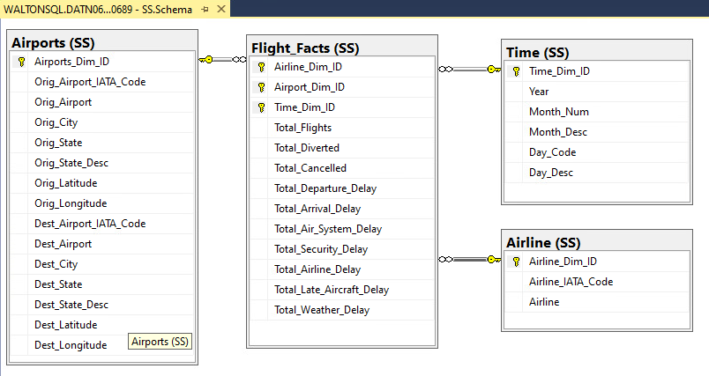

Q3: Explain what the SELECT statement does. What will be inserted into SS.Airline?
The select statement picks the columns that are going to be inserted from the W.Airlines into the new SS.Airline table.
Q4: Explain what the SELECT statement does. What will be inserted into SS.Airports?
It selects all the columns listed on select statement from W.Flights, and SS.Airports receives each unique origin and destination airport.
Q5: Explain what the SELECT statement does. What will be inserted into SS.Time?
It selects the unique Year, Month, Month_Desc, Day, Day_Desc from W.Flights to be inserted into the SS.Time table.
Q6: Explain what the SELECT statement does. What will be inserted into SS.Flight_Facts?
The select statement counts how many flights there are for each airline, and sums up different metrics like diverted, cancelled, departure_delay and inserted into the SS.Flight_Facts.
Q7: Snip and paste your CheckSums worksheet, including the tab, into your Word document.
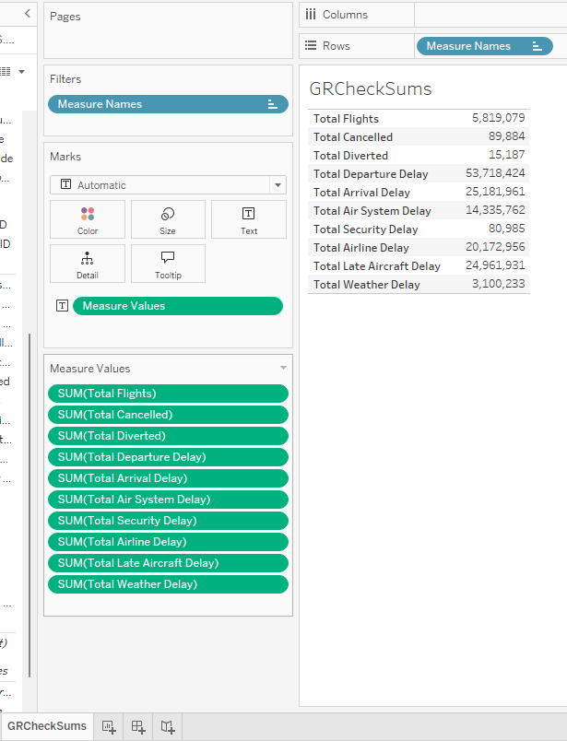

Q8: Snip and paste your calculated fields worksheet, including the tab, into your Word document.
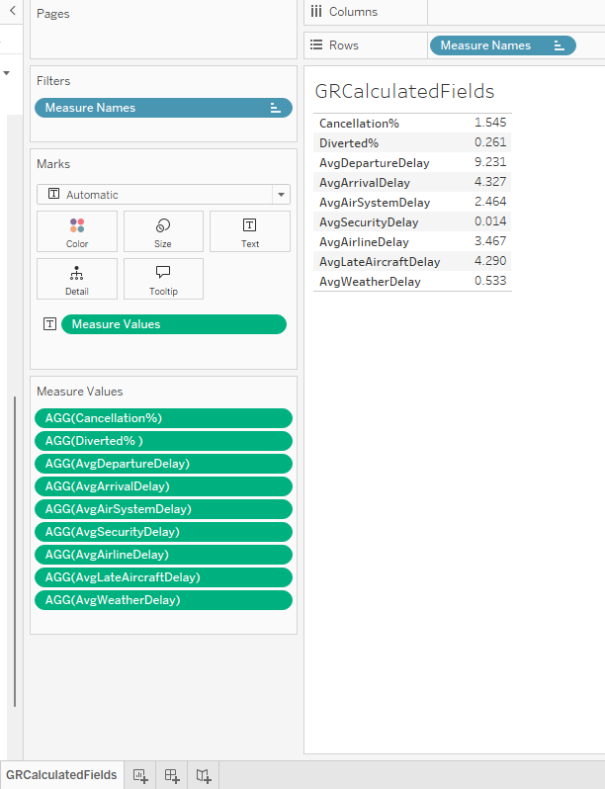
Q9: Discuss what you learned about the airline performance from these measures
Most flights are delay because of departure delays and compare to the amount of total flights there is (5,819,079) there are not many flights cancelled (89,884), 1.55% of flights are cancelled.
Q10: Snip and paste your basic comparisons worksheet, including the tab, into your Word document
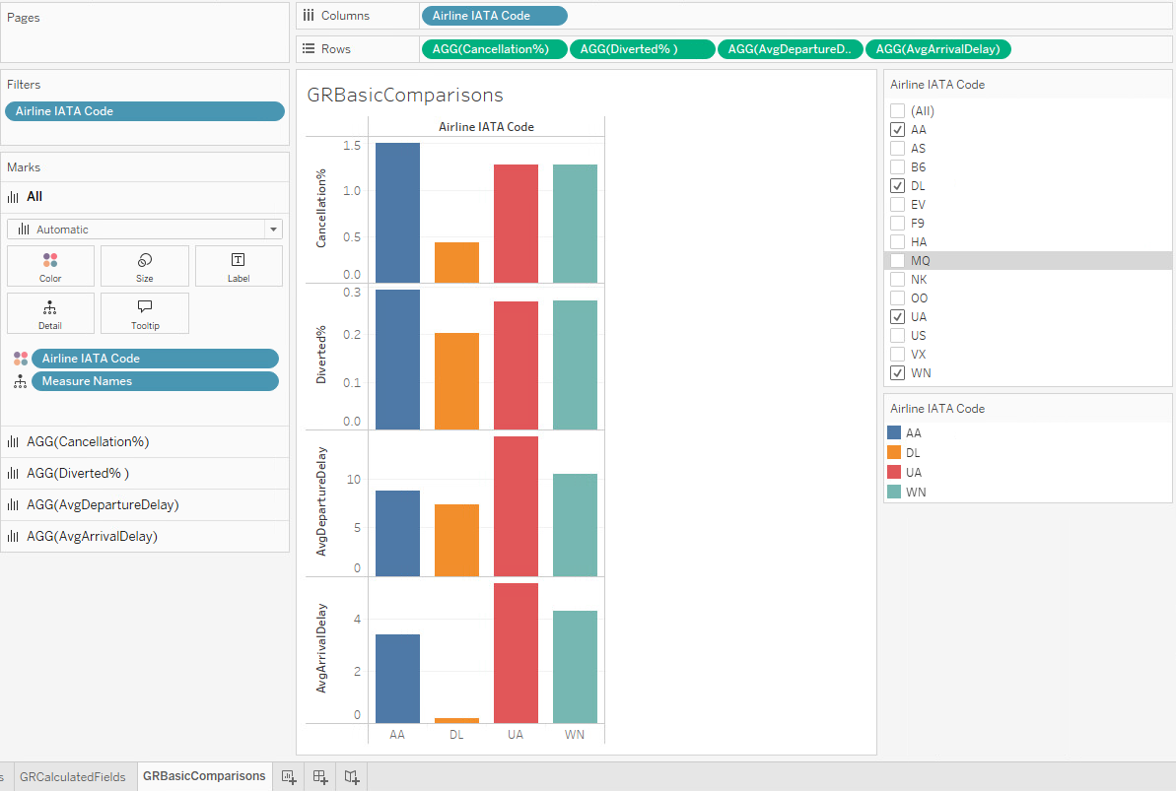
Q12: Snip and paste your cancellation percentages worksheet, including the tab, into your Word document.
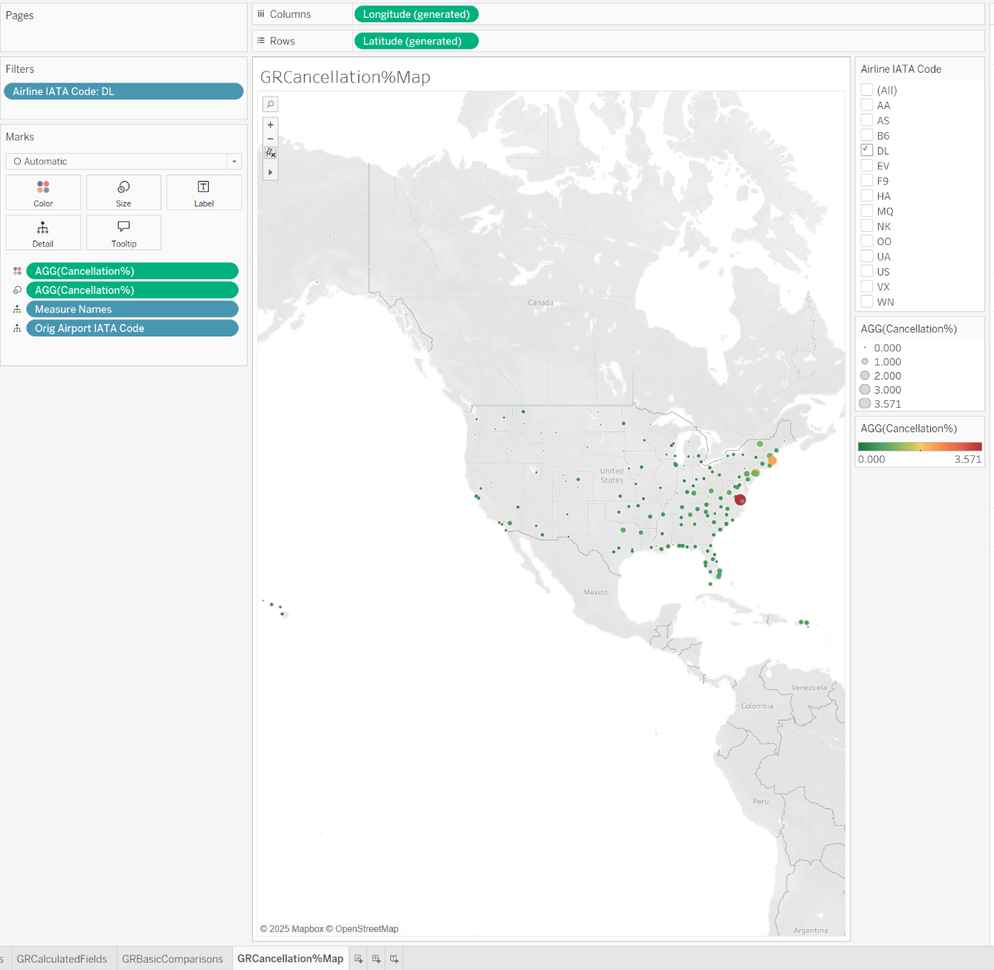

Q13: Determine Delta’s problematic airports and their cancellation percentages. Include them in the
response to this question.
Delta's most problematic airports include PHF at 3.571%, BOS at 2.128%, LGA at 1.953%, BTV at 1.111%, JFK at 1.093%, and MHT at 0.996%.

Q13: Snip and paste your own analysis worksheet, including the tab, into your Word document.
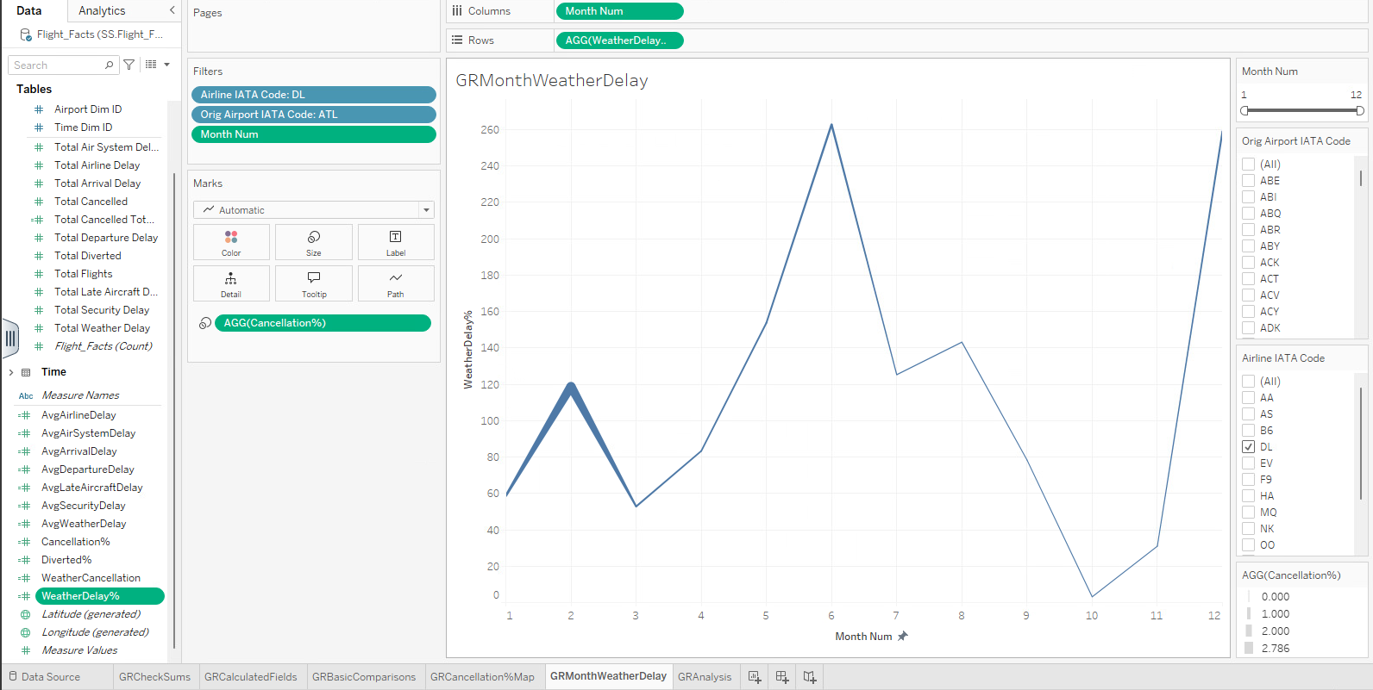
Q14: Describe the new information your visualization could provide Delta Airlines managers as well as
how they might use it
The graph shows the trend over a 12-month period on how many flights were delayed due to weather, and the thickness of the line represents what months had higher cancellations%. You can filter it by airport to find out if a weather delay could lead to a cancelation and to prepare for months when weather cancelation is higher than usual.

